Quick guide for the Intelligent Lighting Systems lighting controller.
Items in Red are functions with explanations at the end of the guide
This version is valid for controllers purchased Late Nov 2017 onwards.

Reference images:
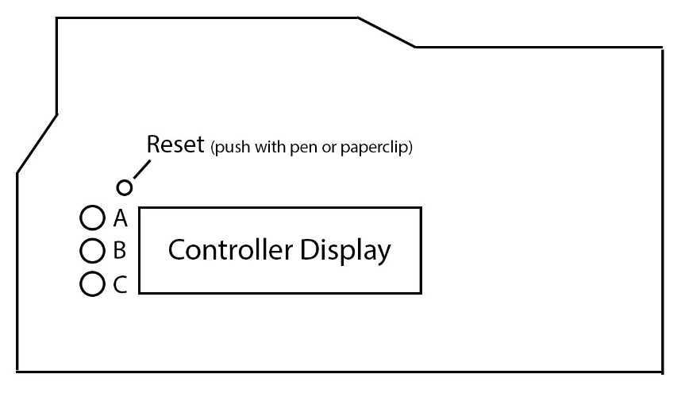
Controller (Top):

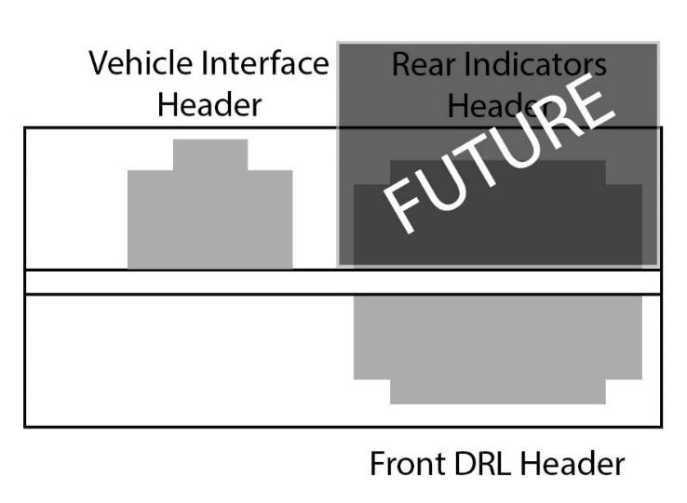
Controller (Header Side):

Slide switch for Auto Learn on this side ->

Controller (Bottom Side):
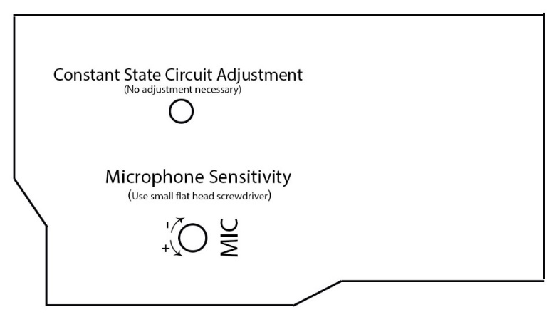

<- Requires a 5/64” (~2mm) flat blade screw driver

In ROAD MODE:
- Button A
  - <1 sec (tap)
    - Cycle Modes (Road > Visualizer >Sound > Demo)
  - >2 sec
    - Manual Blinker Speed
  - >4 sec
    - Auto Learn Feature
- Button B
  - <1 sec (tap)
    - Cycle through pre-programmed DRL (background) colors (Please consult your local laws in regards to which colors are road legal on the front of vehicles in your area!)
      - White (Default)
      - Red
      - Green
      - Blue
      - White
      - Lime Green
      - H.V. Green
      - Teal
      - Purple
      - “Manual” (Loads color from memory)
  - >1 sec
    - Cycle through pre-programmed blinker (foreground) colors (IT IS NOT RECOMMENDED TO CHANGE THIS, AMBER IS THE ONLY DOT LEGAL COLOR FOR TURN SIGNALS AT THE FRONT OF VEHICLES)
      - Amber (Default)
      - Red
      - Green
      - Blue
      - White
      - Lime Green
      - H.V. Green
      - Teal
      - Purple
      - “Manual” (Loads color from memory)
  - >3 sec
    - Enter Manual Color mode.

- Button C
  - <1 sec (tap)
    - Cycle through pre-programmed Blinker patterns
      - Pattern 1: Normal Blink (Blink ON -> Blink OFF)
      - Pattern 2: Blink ON -> Wipe OFF
      - Pattern 3(default): Wipe ON -> Wipe OFF
      - Pattern 4: Chunk ON -> Wipe OFF
      - Pattern 5: Chunk ON -> Blink OFF
      - Pattern 6: Chunk ON -> Chunk OFF
  - > 2-3 sec* [this function is only available after 11/20/2017]
    - Cycle thru pre-programmed start up animations. (will use DRL color)
      - Pattern 1(default): “Ramp up”
      - Pattern 2: “Wipe on”
      - Pattern 3: “Look around”
      - Pattern 4: “Blink”

  - > 3-5 sec
    - Save all current settings: Blinker pattern, Blinker animation speed, DRL color, Blinker color.

  - > 7 sec
    - Revert all settings to Factory:
      - Blinker Pattern: 3
      - Startup animation: 1 [available on controllers after 11/20/2017]
      - DRL color: White
      - Blinker color: Amber
      - On Time: 500ms
      - Off Time: 500ms

In VISUALIZER MODE:
Note: If it looks like the mic is being over powered (ie: the animation is full on and not responding correctly to louder noises) try lowering the sensitivity of the mic (thru the ‘MIC’ hole, use a very small flat blade screw driver to turn the trim resistor. Counter clockwise – More sensitive. Clockwise – less sensitive. If it is still too loud, wait 30 seconds, the program should attempt to adjust to the louder noises, if after 30 seconds it is still not responding, then the noise is too loud
- Button A
  - <1 Sec (tap)
    - Cycle Modes (Road -> Visualizer -> Sound -> Demo)
- Button B
  - <1 sec (tap)
    - Cycle Animation in Visualizer (Pulse > PalettePulse>Traffic>Snake>PaletteDance> Glitter> Paintball)
- Button C
  - <1 sec (tap)
    - Cycle Pallet (colors) in Visualizer (Rainbow > Sunset > Ocean> PinaColada> Sulfur >No Green)

In SOUND MODE:
Note: If it looks like the mic is being over powered (ie: the animation is full on and not responding correctly to louder noises) try lowering the sensitivity of the mic (thru the ‘MIC’ hole, use a very small flat blade screw driver to turn the trim resistor. Counter clockwise – More sensitive. Clockwise – less sensitive.
- Button A
  - <1 Sec (tap)
    - Cycle Modes (Road -> Visualizer -> Sound -> Demo)
- Button B
  - <1 sec (tap)
    - Cycle animation (VU meter <-> Brightness)
- Button C
  - None
    - Cycle animation colors (presets), will initially run with current DRL color:
      - White (Default)
      - Red
      - Green
      - Blue
      - White
      - Lime Green
      - H.V. Green
      - Teal
      - Purple
      - “Manual” (Loads color from memory)
In DEMO MODE:
No buttons function. Demo will play through all 6 patterns, and several color/rainbow animations before returning to “Road mode”

Manual Blinker Speed Setting:
Pressing A and B will increment the On/Off time (respectively) by 100ms (0.1 seconds) up to a maximum of 1500ms (1.5 seconds) before rolling over to 0. Pressing C (for more than 1 second) will save the current On/Off animation times and return to “road mode”
- On Time, in milliseconds. Total amount of time the controller will spend playing the ON animation and holding.
- Off Time, in milliseconds. Total amount of time the controller will spend playing the OFF animation and holding.

The controller will take the On/Off time and split it into 3rds. It will allocate 2/3’s of the time to playing the animation, and 1/3 of the time in ‘static’ mode, or holding the LEDs in their last state. The shorter the time, the faster the animation will play. The longer the time, the slower the animation will play.

Example:
If On Time is set to 600ms (0.6 seconds): The controller will adjust the ON animation to cover 400ms, then hold all LEDs ON for 200ms
If Off Time is set to 1200 ms (1.2 seconds): The controller will adjust the OFF animation to cover 800ms, then hold all LEDs OFF for another 400ms.

Auto Learn feature:
The auto learn feature lets the controller sense the actual blink rate of the vehicle, then calculates how fast the animations must be in order to match the vehicle’s original blink speed. This may be desirable to some. But if you are getting rid of your OEM markers entirely, then this feature is pretty irrelevant.
Before entering the auto learn feature:
- The vehicle should be in an idle state (no turn signals or brakes applied).
- The slide switch on the side of the controller must be flipped towards the connector end of the unit.

Once you enter the Auto Learn Program, the controller will prompt you to turn on the vehicle’s RIGHT blinker. Once you start the right blinker, the controller will then monitor the right blinker input. It will take several readings and average them, displaying the averaged ON/OFF times (in milliseconds) on the display. Once the calculated ON/OFF times have been displayed, the controller will return to ROAD mode, and the ON/OFF times will be applied to the turn signal animations.

THE SLIDE SWITCH ON THE SIDE OF THE UNIT MUST BE FLIPPED BACK TO THE ORIGINAL POSITION (opposite of the connectors) otherwise erratic turn signal animations may occur!

Note: When the slide switch is in the left hand position (towards the headers) switch bypasses the “constant state” circuit. Meaning that the controller will sense each individual blink by the vehicle. This may be desirable for animations that are fast enough to complete a cycle within the vehicle’s blink timing. If you want, you can play around with manual timing and this setting if you want to, this would allow you to fine tune the blinker animation timing.

However; the intention is that this switch should be set to the right side (away from the headers) to operate as intended.

Manual Color Setting:
It is not recommended to enter this mode unless absolutely necessary. This mode can wipe both Background and Animation color settings. If you wish to adjust the background (DRL) color only and keep amber turn signals, the quickest way to do this is to do the following:
- Enter the manual color mode and enter the background color selector (background of display will be white)
- Adjust the RGB values until you have reached your desired color.
- Save.
- Reboot the controller.
- While in road mode, tap the B button until the display reads Back: Manual.
- Hold C button for 2-3 seconds to Save your settings. Now your DRL color will be saved and Amber will remain as your turn signal color even if the controller is powered off.

This mode will allow you to manually set the colors of the DRL and Turn Signal colors by adjusting the red/green/blue values individually:
There are two modes for this function: The “Background Color” mode and the “Foreground Color” Aside from the name, both modes can be differentiated by the display:
- When in “Background Color” mode, the background of the display will be white, and the text will be black.
- While in “Foreground Color” mode the background will be black, while the text will be white.
You will enter the Background setting first:
- A – Increment Red (logarithmically)
- B – Increment Green (logarithmically)
- C – (Tap): Increment Blue (logarithmically)
  - (Hold 2-4 seconds): Change between Foreground and Background Color Selector
  - (Hold 5+ seconds): Save current color in current mode

The reason why the values increment logarithmically is twofold:
- While the A and B buttons can be held down to increase the values quickly, the C button functions triple duty as the Blue value when tapped, swap between background and foreground when short hold(2-4sec), and save when long hold(5sec+). So you must release the C button every time to increment the value… so tapping it 255 times to get full blue would be… tedious.
- The way our eyes perceive brightness of light is relative, we perceive the differences in dim colors to be bigger than bright ones: So you will notice the difference between the values (range: 0 – 255):
  - 10-20 <- The difference here would be quite noticeable
  - 230-250 <- But the difference here would be hardly noticeable:
    - Even though the difference between the 2nd one is twice as large (250-230 = 20) as the first example (20-10 = 10).
  - Additional reading can be found here: http://www.pathwaylighting.com/products/downloads/brochure/technical_materials_1466797044_Linear+vs+Logarithmic+Dimming+White+Paper.pdf

